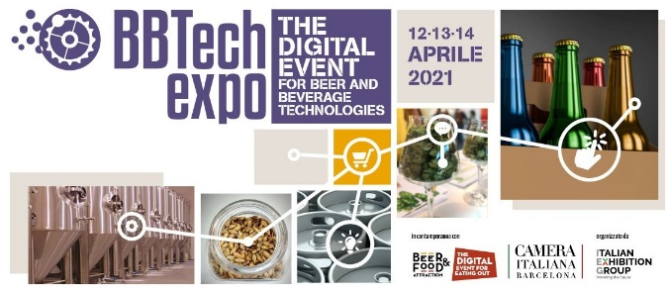

COMPANY PROFILE
Company:
Name: | Surname:
Position in the company:
Address:
ZIP code: Town: Country:
Tel.: |  | Skype Contact:
E-mail: |  | Mobile:
Website: |  | No. of employees:
Turnover per year (only in Euros): |  | Year of foundation:
PLEASE INDICATE THE CORE BUSINESS OF YOUR COMPANY: |  | POSITION IN THE COMPANY (tick only one choice):
- Beer producer  - Beverage producer  - Mineral water and soft drink producer  - Wine producer  - Oil and liquid food producer  - Importer/Distributor of beverage technologies  - Other (please specify)  ……………………………………………………………………………………………………………………………… |  | - Owner/CEO  - Director/Manager  - Brewmaster  - Consultant  - Purchasing Manager  - Technician/Installer  Responsibility Level:  - Final Decision  - Operative  - Plan/Organize

Please describe briefly your activity (only English):

INTERPRETER SERVICE
- I speak English fluently so I do not need interpreting service

- I need interpreting service from the following language:………………………………………………………………..

